Tool Chain:
For developing this project, the following tools will be used –
- C# Language.
- SQL / MySQL Query Language.
- SQL Management Studio.
Conclusion:
Though it is tough to get the attributes of a bank management system database from the banks for security issue, the project will use general outline of banking system. But, there will be kept option to modify anything needed. There is a future plan to expand its scope to the online application.
References:
- Bangladesh Bank – Credit Information Bureau.
- South East Bank Limited, Haji Hanif Complex (1st floor), 12 & 13, Khan Jahan Ali Road, Khulna.
- United Commercial Bank Limited, Khan Jahan Ali Road Branch, Khulna
- Dutch Bangla Bank Limited Useful Forms - http://www.dutchbanglabank.com/electronic_banking/forms.html
- Bank Management System –
http://www.slideshare.net/vivekk1989/bank-management-system-1852764
- JAVA J2EE Tutorial – Enterprise Beans –
http://ulm.uni.udm.ru/~oam/j2ee/tutorial/1_3-fcs/doc/Ebank2.html
- BankSystemVedio.mp4
http://www.youtube.com/watch?v=oDKvwBWBIbc
Introduction:
Date of Submission: September 26, 2013
The domain “Banking System” keeps the day by day tally record as a complete
banking. It can keep the information of account type, account opening form, deposit,
withdrawal, and searching the transaction, transaction report, individual account
opening form, group account. The exciting part of this project is; it will display transaction
reports, statistical summary of account type and interest information.
Description:
a) System Design:
In real world application for bank management, many types of system designs are followed. There could be different application for client, admin, and employee. There may have web application in addition to desktop application. All that design depends on system designer and bank authority. For simplicity, in this project there will be one application with different user interface. The whole process is described below-
- General UI: A general UI will be provided to all the users. This UI shows the general features to customers and employee both.
- Log in: The application will require log in mandatorily. Now, before log in, the user have to define whether he is admin, client or employee. User ID will be the key to verify the type of the user. Any kind of wrong information will give error report with appropriate suggestions.
- Verification: Depending on the type of user, there will have a mechanism that will verify the user. After verification, the mechanism will provide appropriate user interface to the user.
- UI for Customer: Customer can access the system either by going to the bank or ATM booth. There will have different user interface –
- Customer UI.
- ATM Booth UI.
- UI for Employee: Employee can use two types of UI.
- Accounts UI.
- Admin UI.
- Filer Information: A mechanism of filtering will be provided. It will provide full control of database to admin and partial control to accountant and customer. Admin will have full control of read and write. Confidential data will be hidden from customer or accountants.
- Database: All the information of the banking system will be preserved in database tables. The relationship between the entities will provide appropriate information to the user.
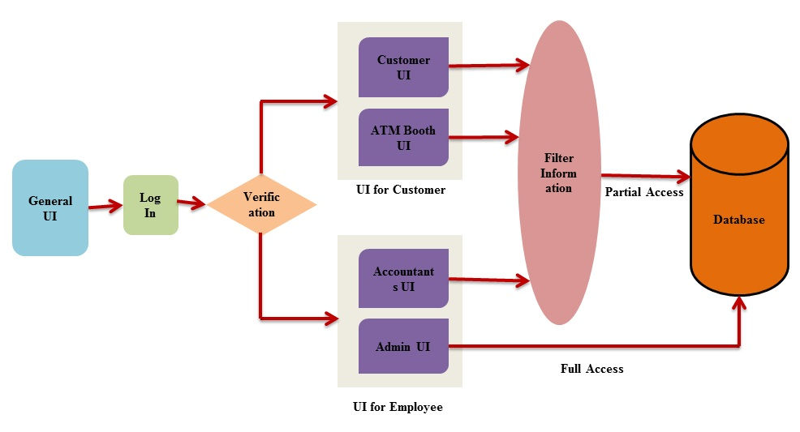

Figure: System Design for Banking Enterprise.
ER DIAGRAM FOR BANKING MANAGEMENT SYSTEM

BRANCHES
Address
Name
Address
ess
Branch No.

ACCT
LOANS
Amount
Types
Loan-no
OD
Term
Types
Code
Account-no
Balance
Type
Current
Savings
Short Notice
A_C
L_C
Address
Country
District
Sub-District
Village
Street
Personal info
Basic Information
CUST_ID
Father’s Name
Mother’s Name
Age
Date of Birth
Name
Mobile No
Passport No
National Id
Photo
Profession
Short
Last
First
Middle
BANK
BANK_BRANCH
Loan
Account
CUSTOMER

